- Launch one EC2 instance using Amazon Linux 2.
Clicked here to launch an instance
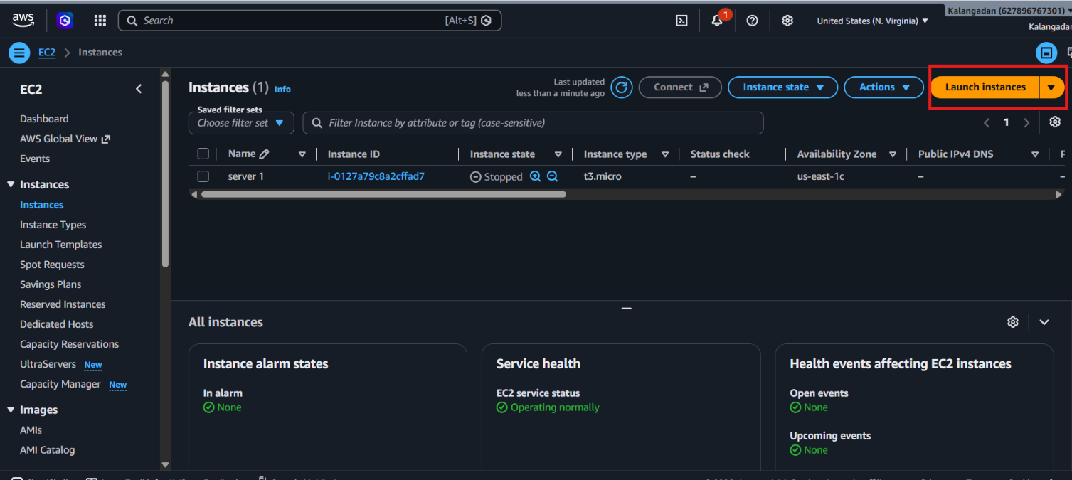
Keep name of a web server and select any OS
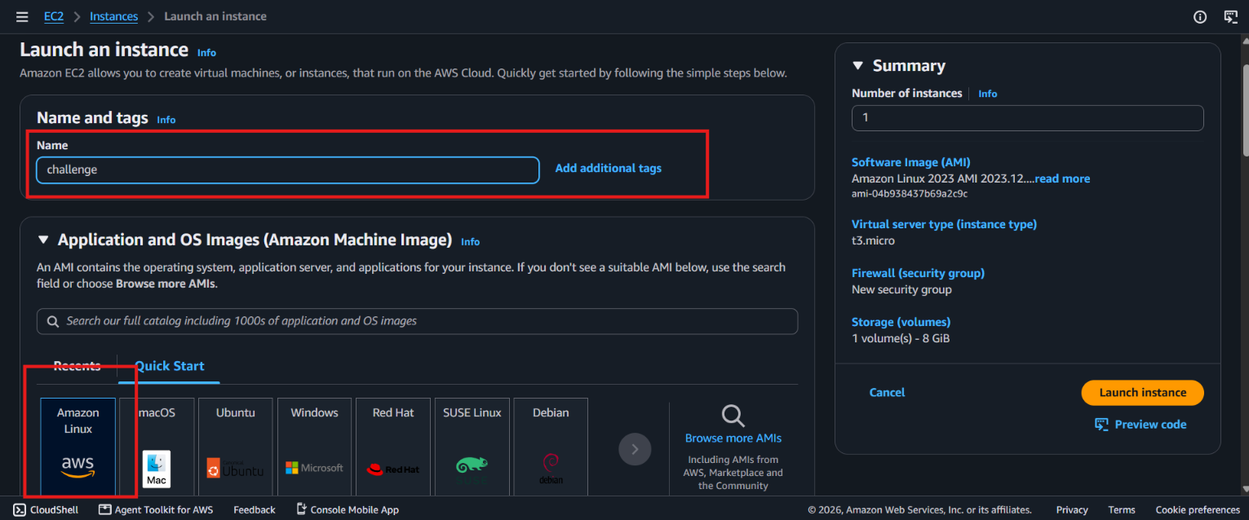
Selected micro to less billing and selected key which was already in the download folder

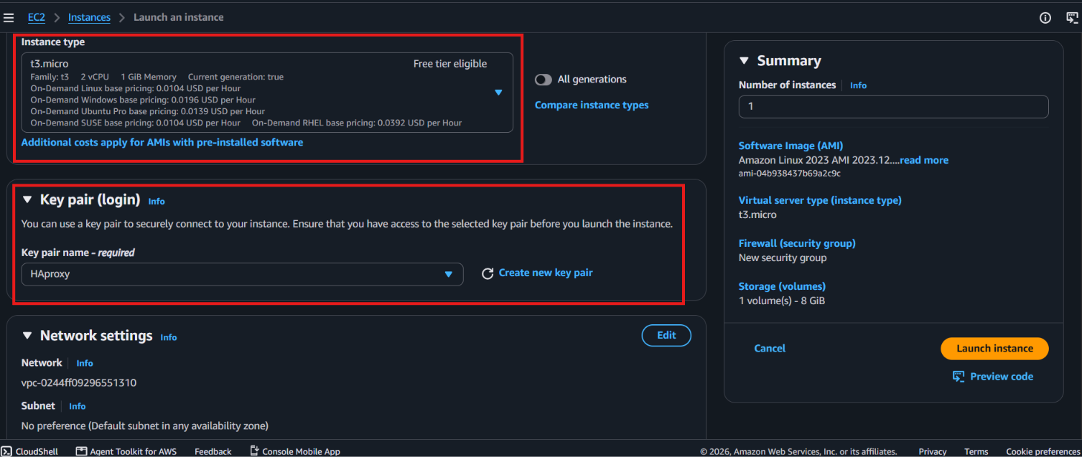
Selected existing group
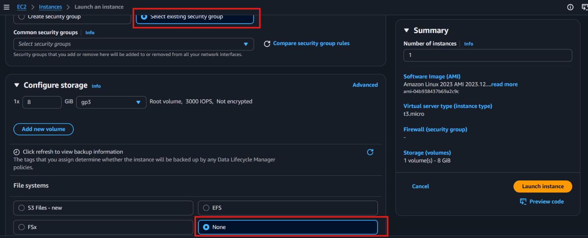
Connected to the CLI
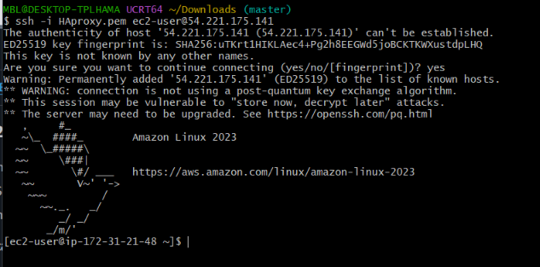
- Install Docker.
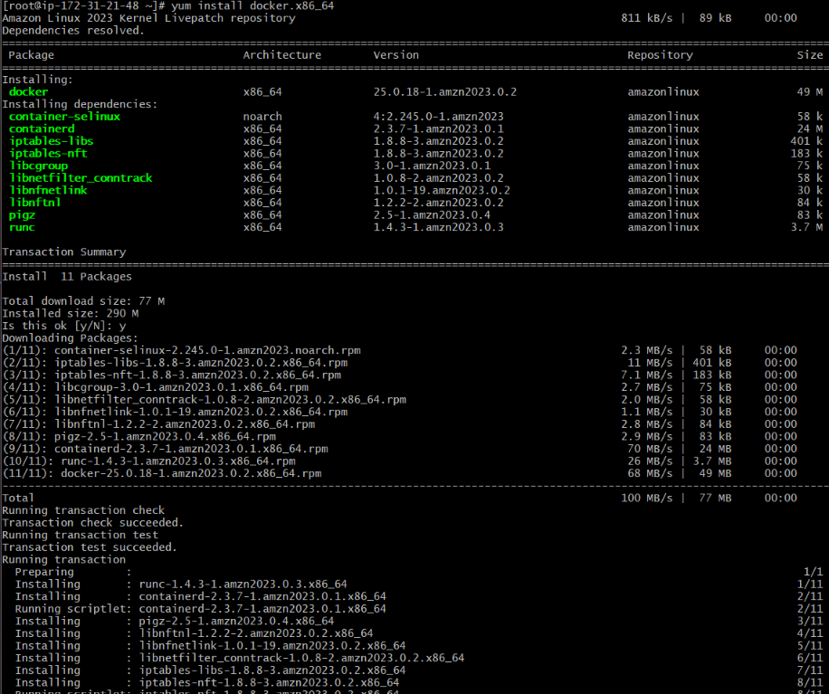
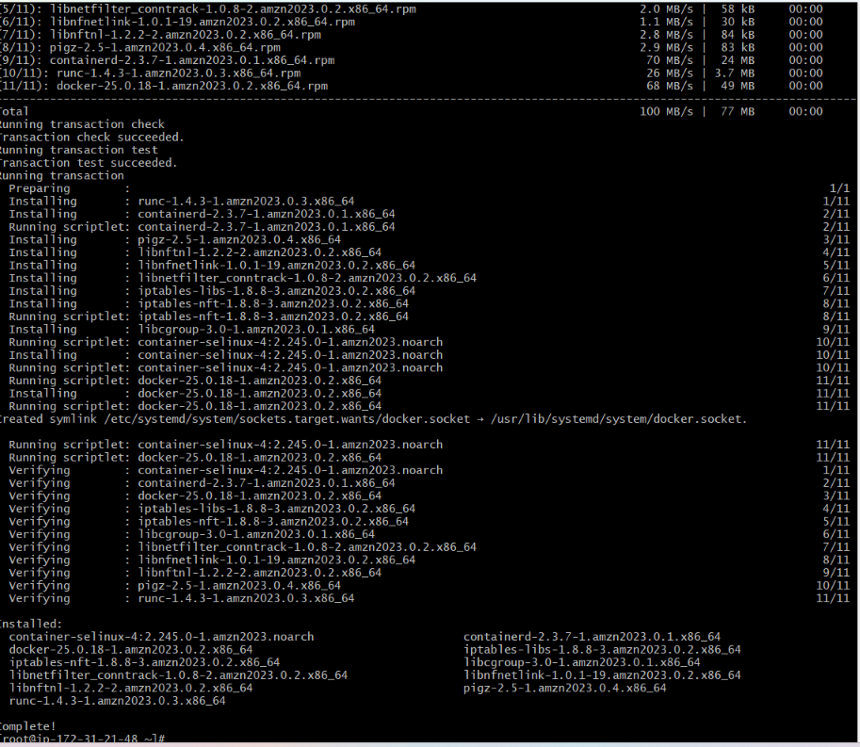
Successfully installed the docker

- Install Jenkins.
Installed the java-17 to run Jenkins based on this
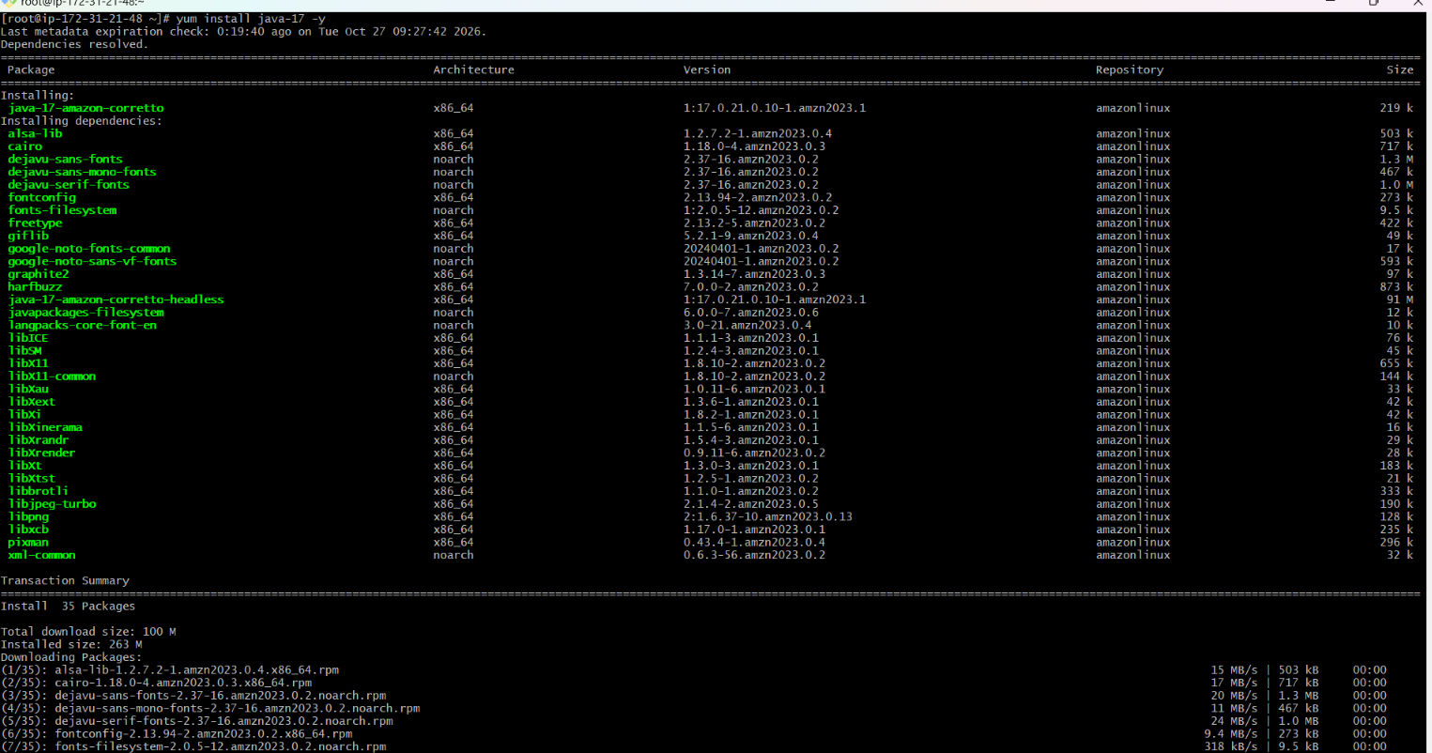
Fist we need to add Jenkins repo and import key in local system through URL to install Jenkins otherwise Jenkins will not install
Repo URL: sudo wget -O /etc/yum.repos.d/jenkins.repo https://pkg.jenkins.io/redhat-stable/jenkins.repo
Import key: sudo rpm --import https://pkg.jenkins.io/redhat-stable/jenkins.io-2023.key
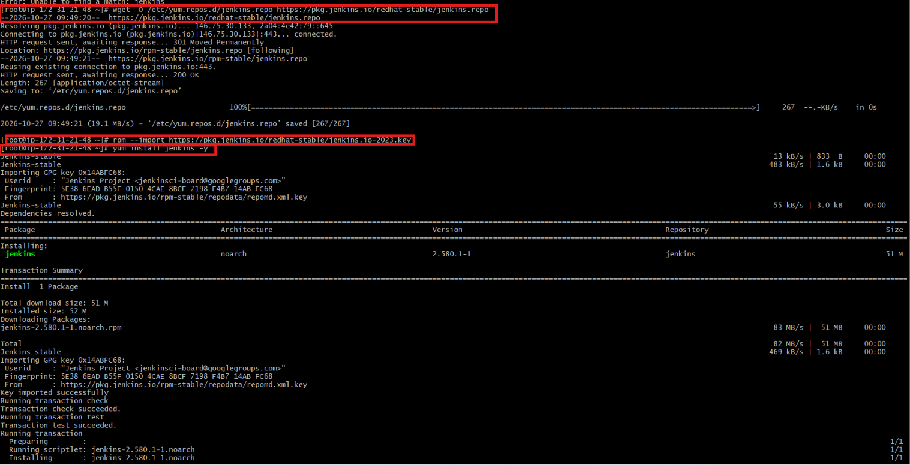
sudo systemctl daemon-reload
sudo systemctl restart jenkins
sudo systemctl status jenkins
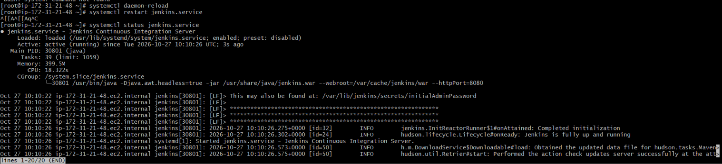
Then
Command on terminal to get password: cat /var/lib/jenkins/secrets/initialAdminPassword

- Install Apache.
Installed httpd
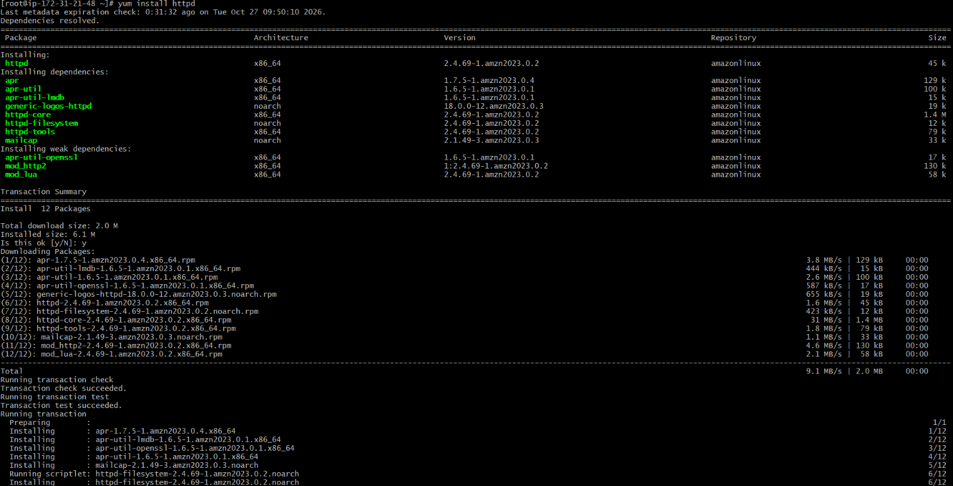
Started and checked the status
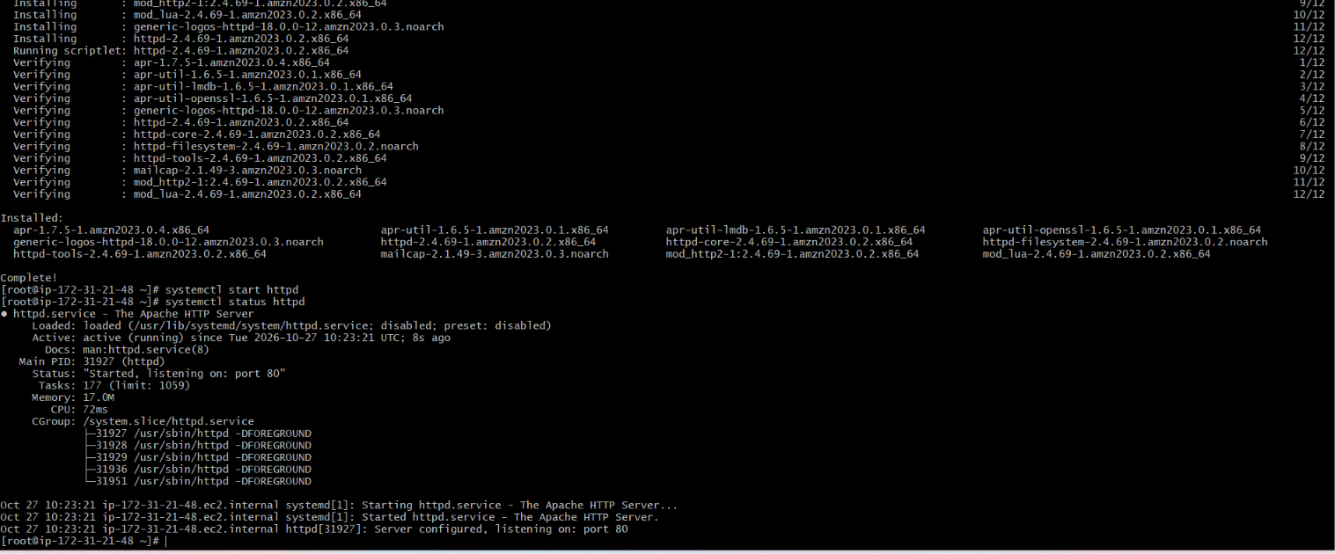
Httpd has been successfully run
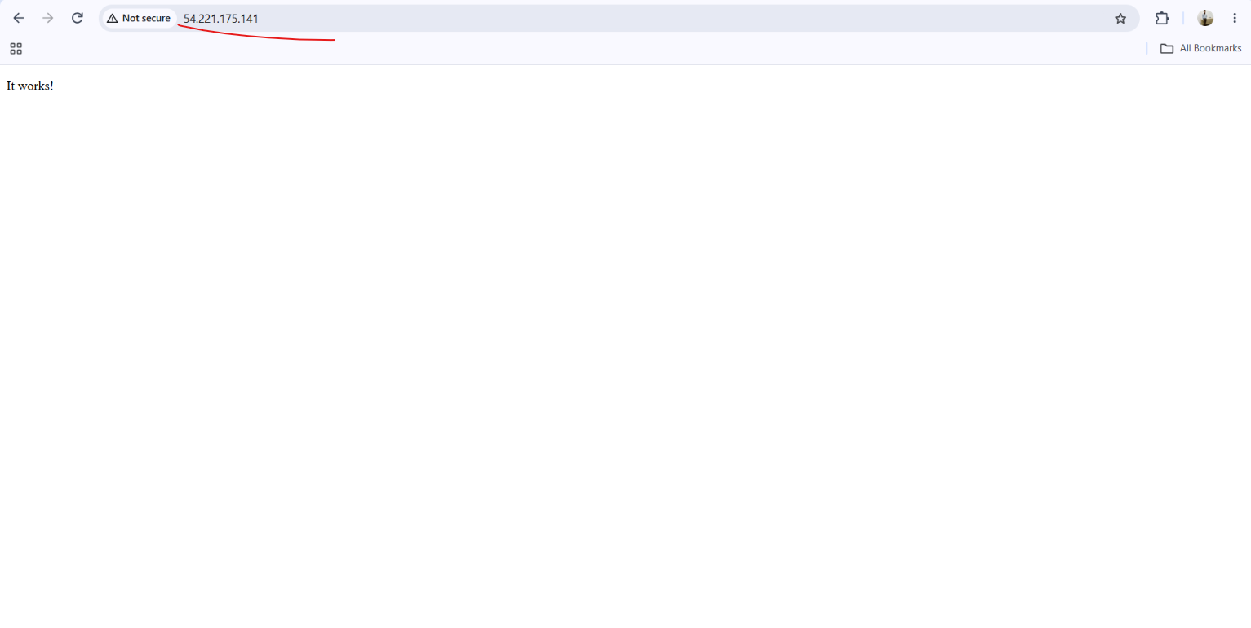
- Install Nginx.
Installed the nginx
Find the nginx.conf: find / -name nginx.conf (/etc/nginx/nginx.conf)
Then made changes in the nginx pord number 80>81
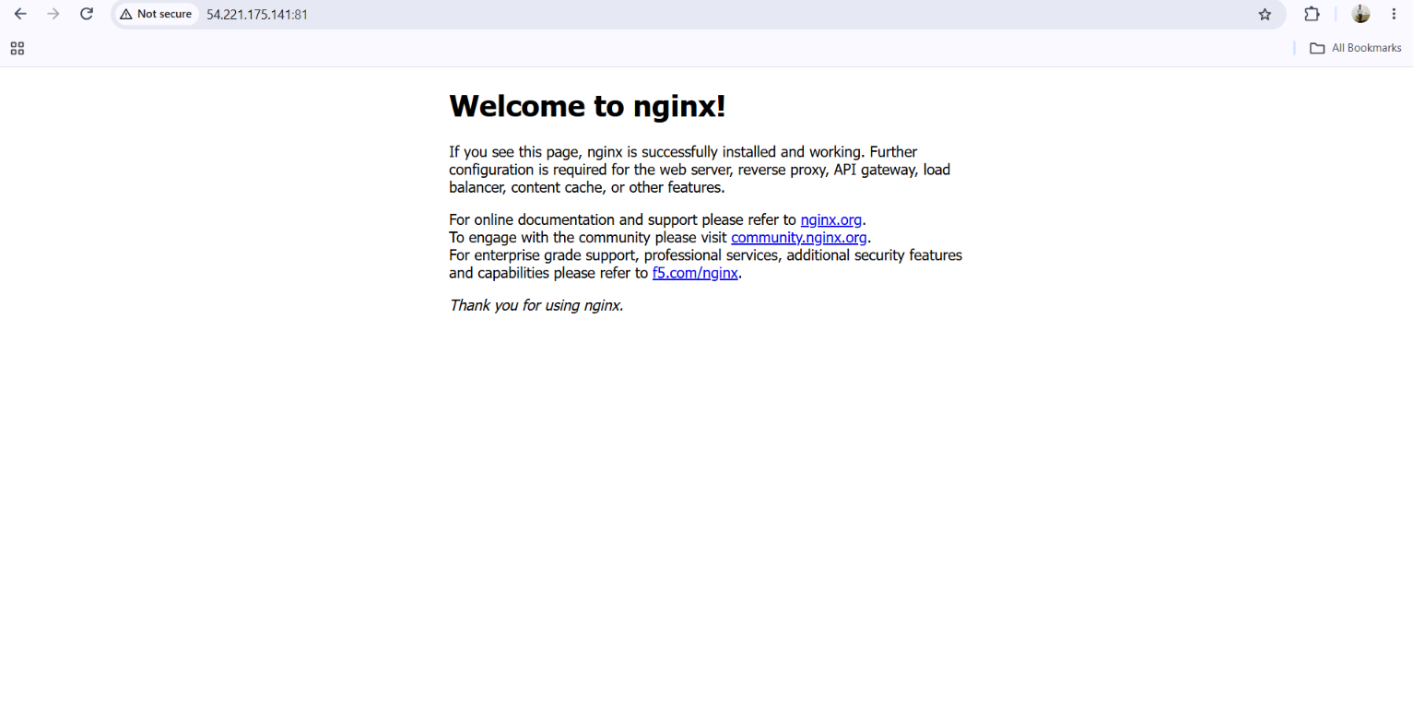

- Install Apache Tomcat.
Installed successfully
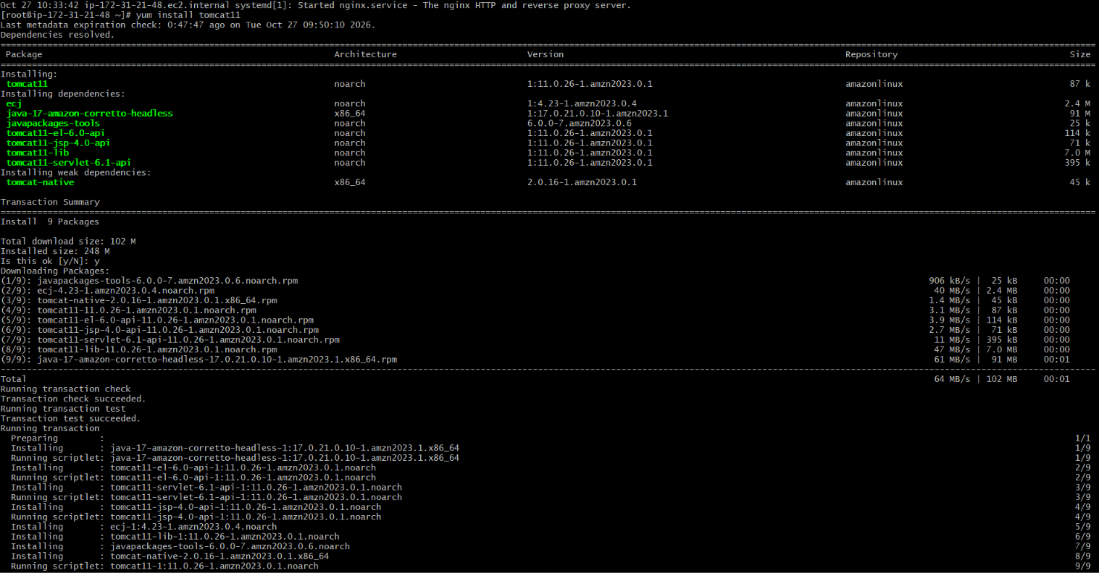
Find the server.xml: find / -name server.xml (/etc/tomcat11/server.xml
Then made changes in the nginx pord number 8080>8082



